Detailed Process Maps Report

**1. Introduction**

This report documents six critical workflows modeled using BPMN and swimlane diagrams. Each diagram illustrates current inefficiencies and proposes streamlined solutions. The processes support HealthFirst Care’s digital transformation and operational efficiency goals.

**2. Workflow Summaries with Diagrams and Insights**

**Workflow 1: Appointment Scheduling**

- Issues: Manual process, scheduling conflicts, delayed confirmation  
- BPMN Features:  
 - Gateway: Is slot available?  
 - Subprocess: Update patient record  
 - Event: Send confirmation  
- Improvement: Self-service booking + automated conflict checks

**Workflow 2: Patient Check-In**

- Issues: Paper forms, long queues  
- BPMN Features:  
 - Gateway: Is appointment verified?  
 - Subprocess: Auto-fill data  
 - Event: Notify department  
- Improvement: Digital check-in and queue management

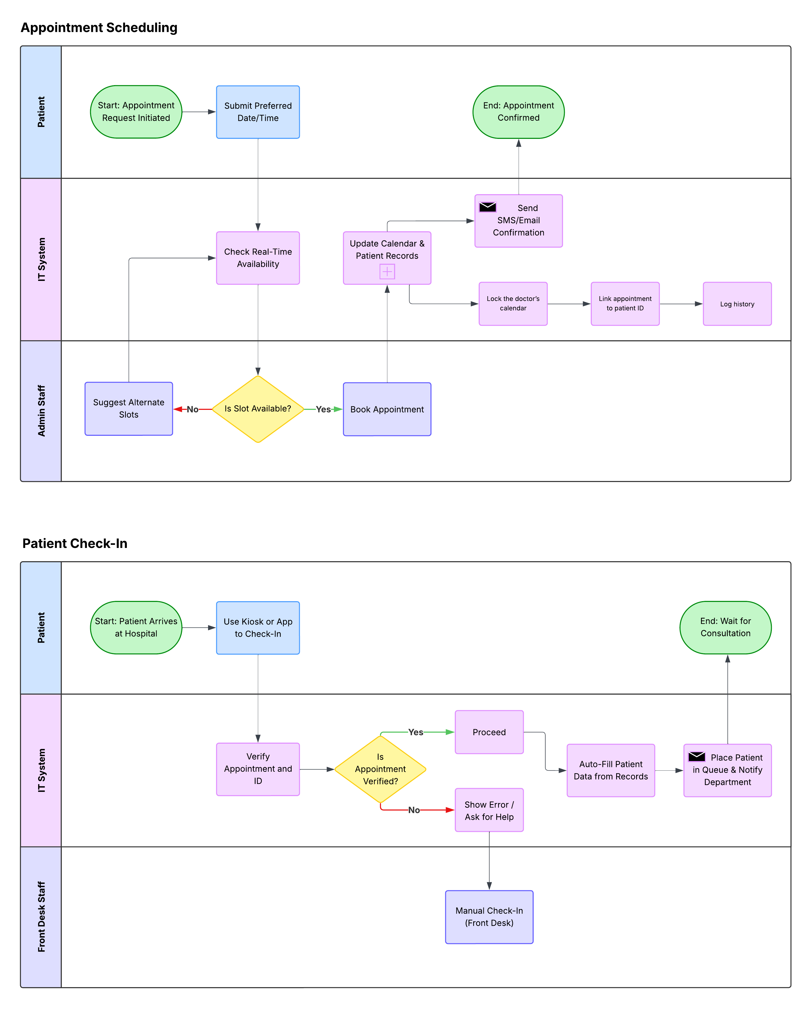

**Workflow 3: Resource Allocation**

- Issues: Manual tracking, inconsistent updates  
- BPMN Features:  
 - Gateway: Is resource available?  
 - Subprocess: Assign or escalate resource  
 - Event: Notify department  
- Improvement: Real-time resource dashboard

**Workflow 4: Patient Treatment**

- Issues: Delayed decisions and diagnostics  
- BPMN Features:  
 - Gateway: Are diagnostics required?  
 - Subprocess: Update central record  
 - Event: Send test results  
- Improvement: Streamlined testing and treatment decision loop

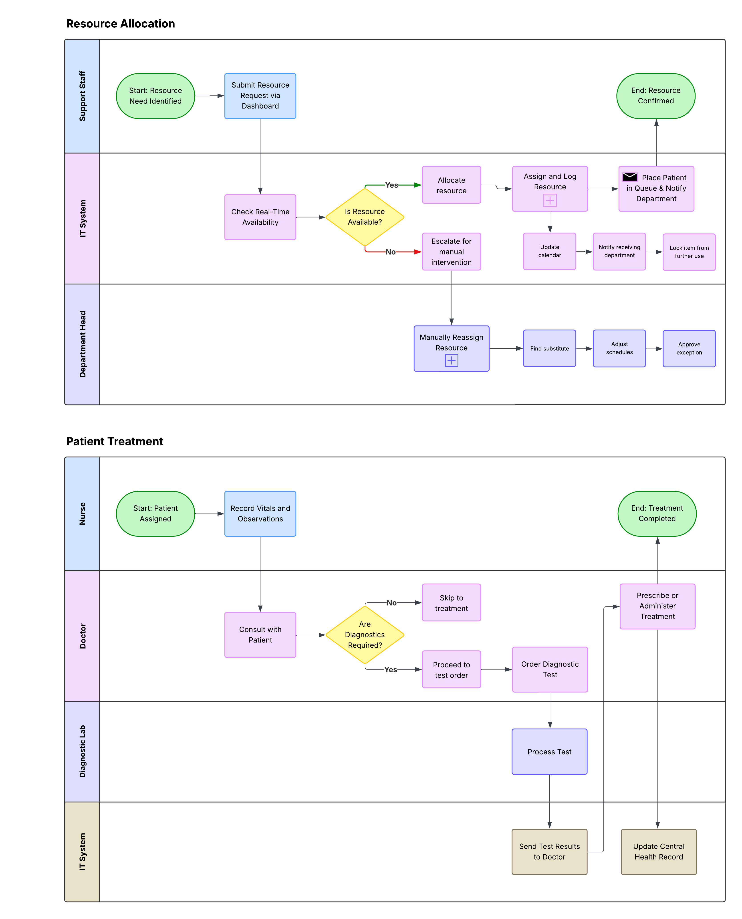

**Workflow 5: Discharge Planning**

- Issues: Missed steps, lack of feedback  
- BPMN Features:  
 - Gateway: Is feedback required?  
 - Subprocess: Generate discharge summary  
 - Event: Trigger feedback form  
- Improvement: Unified discharge checklist and post-discharge loop

**Workflow 6: Interdepartmental Communication**

- Issues: Poor visibility, manual follow-ups  
- BPMN Features:  
 - Event: Route request  
 - Subprocess: Update task status  
 - Event: Notify requester  
- Improvement: Auto-tracked digital ticketing system

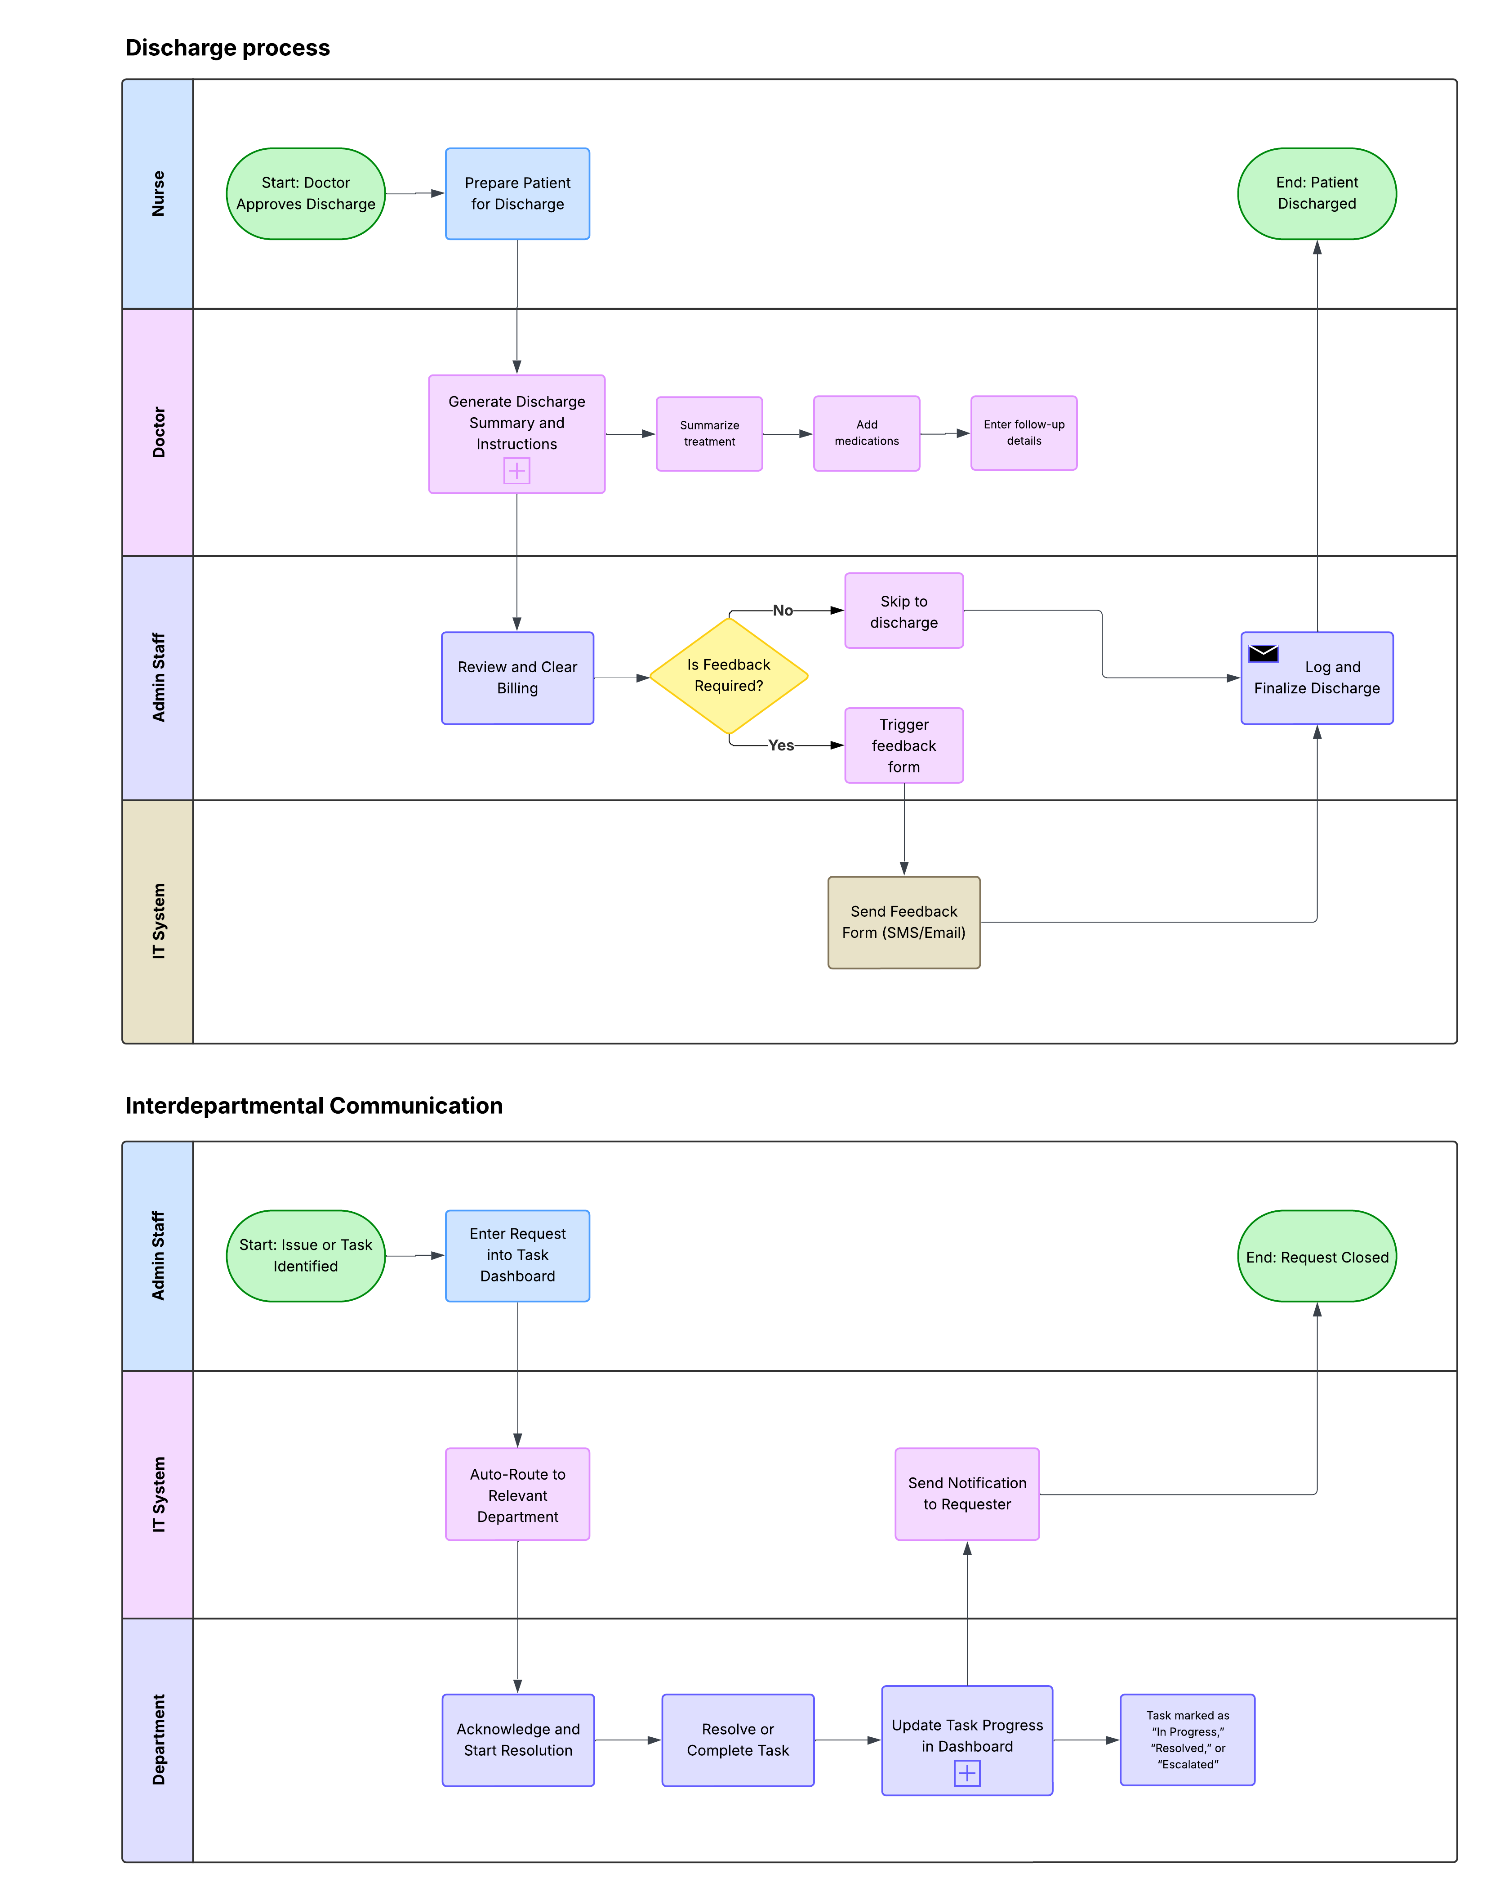

**3. Summary of Proposed Improvements**

- Replaced manual steps with automated tasks  
- Used gateways for decisions and escalations  
- Embedded subprocesses to contain grouped steps  
- Added event triggers for timely handovers  
- Used swimlanes to clarify responsibility per task

**4. Impact Expectations**

• Reduce average patient wait times by 20% within 6 months

• Improve patient satisfaction scores to 8+/10

• Ensure 90%+ availability of critical resources during operating hours

• Enhance data access and communication across all departments